Phillip Efthimion

Week 3 – Homework

#**************************

Please see the attached word document for the Homework.

#**************************

Please note all homework is due submitted on-line by 1PM CST (Dallas) on Saturday February 10.

Please send me an email to [cmaybin@smu.edu](mailto:cmaybin@smu.edu) titled MSDS_8390 - [Last Name] - Week 3 Homework. For example, my submission would be titled MSDS_8390 - Maybin - Week 3 Homework. In the email should be the following attachment containing the answers to the questions below:

* 1 Word document: Please make sure to include your code in the bottom of the document.

Please keep all written answers short – say no more than 4 sentences.

Regards,

Chad

#************************

Homework Section

#************************

Question 1 – “Rule of 72” :

1. At 3.6% return, how long will it take an investment to double?

Y = 72 / 3.6 = 20 years for an investment to double.

1. If an investment doubles in 5 years, what is the approximate rate of return under the rule of 72?

R = 72 / 5 = 14.4. With an approximate rate of return of 14.4%, an investment will double in 5 years.

Question 2 – Given the following Isoquant graph (all graphs copied from HW/other videos):

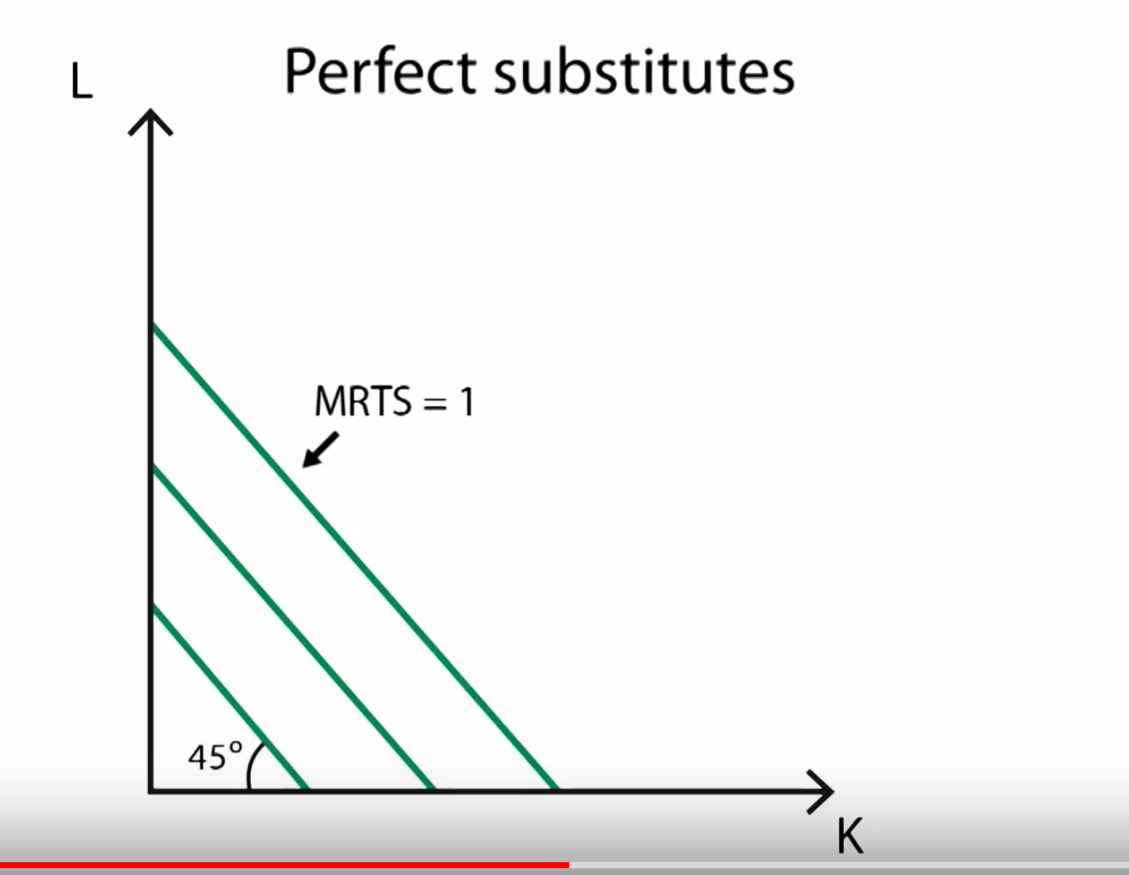

1. What does “substitutes” mean?

Substitute means capital and labor can be interchanged. Even when interchanged, the substitutes will achieve the same output.

1. What is this telling us about the relationship between Labor and Capital?

This tells us that capital and labor can be interchanged along the line since it is a one for one change. It also means that for example we don’t need people, it could be all machines (capital) getting the same amount of output. The opposite of this is also true.

1. Why would this be a “straight” line with a 45-degree angle? Is that relevant?

This is relevant. Since the line is straight at a 45-degree angle, the line has a slope of 1. Since the line has a slope of one, the marginal rate of return when substituted are not decreased.

Question 3 – Given the following Isoquant graph:

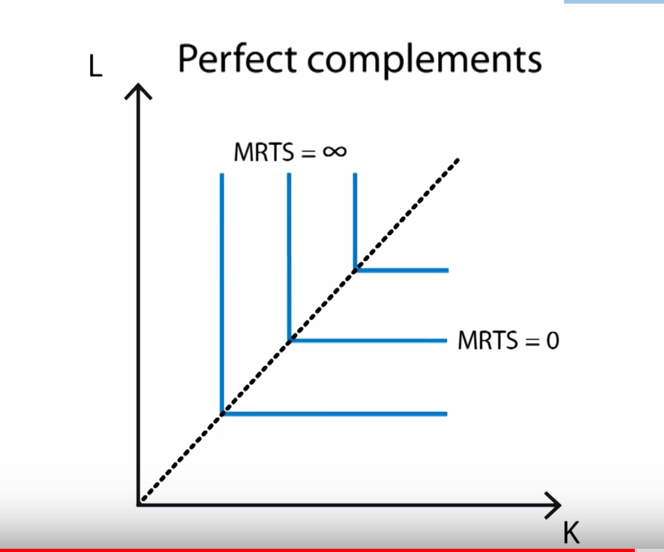

1. What does “complements” mean?

Complements mean things that go together. The example that I use to illustrate my answers below, that we went over in class, is people and shovels. To dig a hole, a person and shovel must be used. A person without a shovel can’t dig a hole. A shovel without a person can’t dig a hole. A person and shovel together can dig a hole. A person and shovel together are complements.

1. What is this telling us about the relationship between Labor and Capital?

It is telling us that a specific number of capital and labor is needed in order to have output. A classic example, which was discussed in class, is people with shovels digging holes. Only going to dig hole when combo of 1 person and 1 shovel. Can’t have more than either and be productive.

1. Why would this be a “straight” line with 90-degree angles at the meeting of Labor and (K) Capital? Is that relevant?

It is a “straight” line because of the consequences when the line is either horizontal or vertical. Using the shovel example, when a company only has x workers to shovel, it needs x shovels. Having x + 1 shovels for x workers does not create any more of an output than only having x shovels. This is an example of when the line is horizontal and has a slope of 0. When the line is vertical, slope = infinity, it mean that is you have x shovels, then even if you have x + 1 workers to shovel, you can only use x workers because that is the amount of shovels you have. You must have the correct number of capital and labor because they are complementary.

Question 4 – Given the following **Isocost** graph:

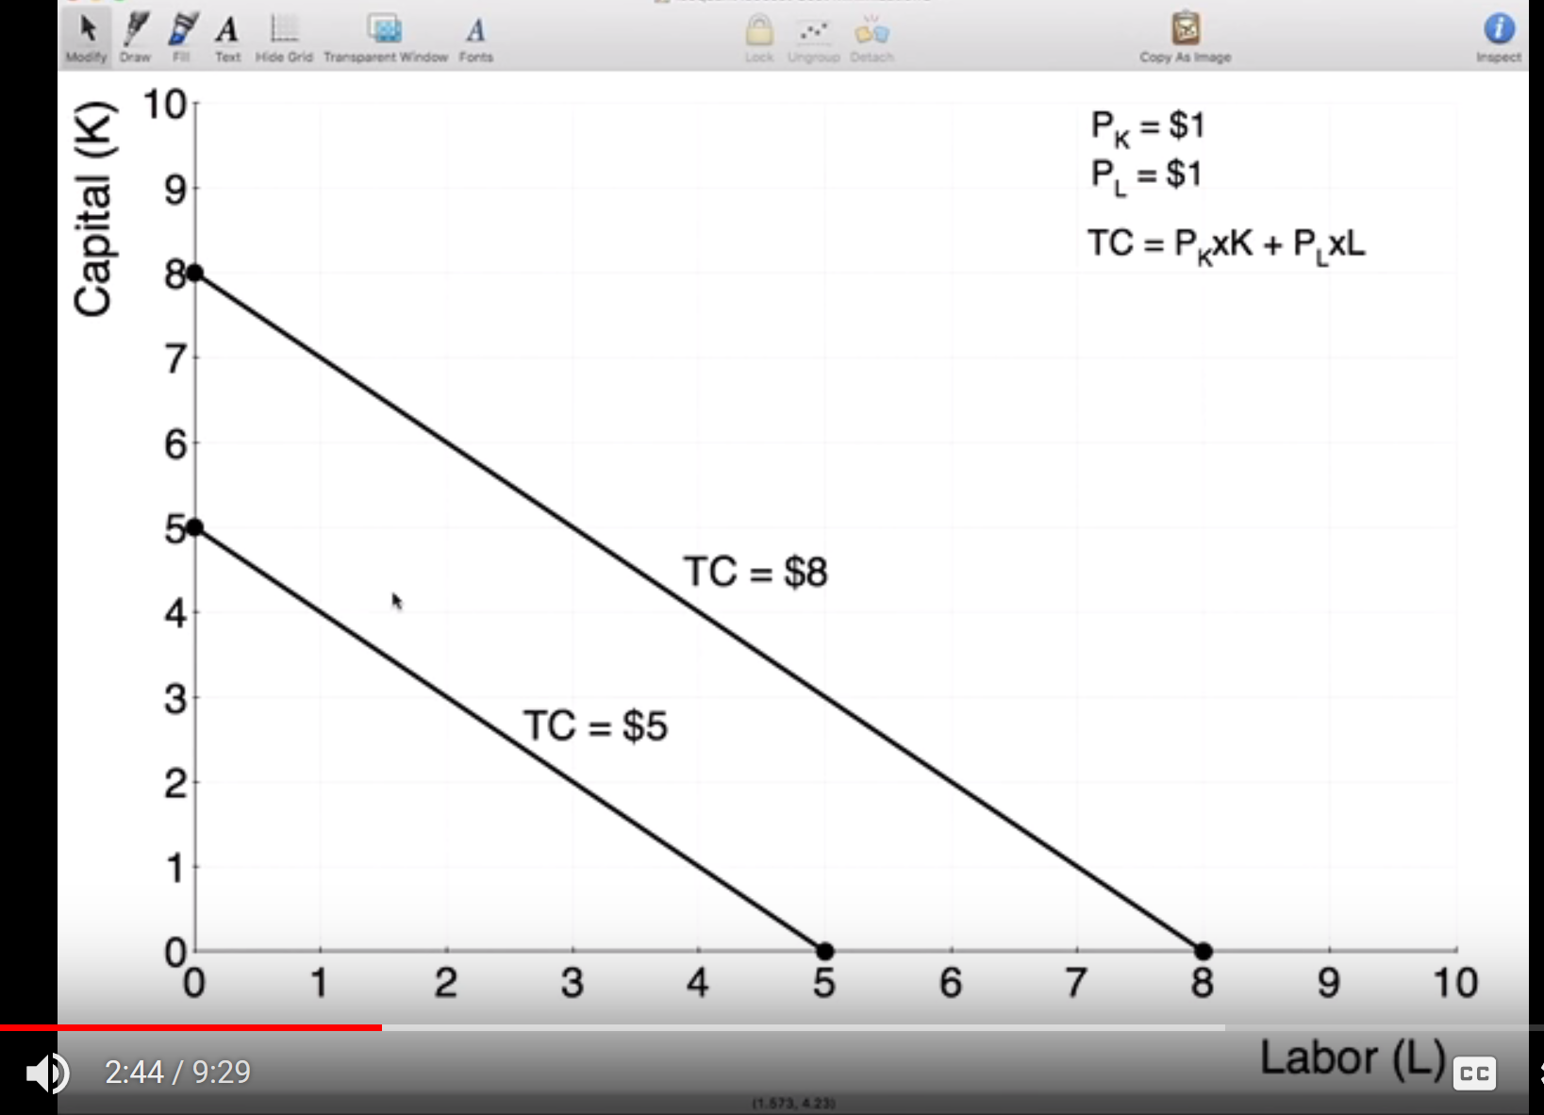

1. What is this telling us about the relationship between Labor and Capital?

It is telling us the cost of the output for capital and labor. It is telling us that for Labor = 5 and capital = 5, then TC = $5. Also, for L=8 and K=8, TC=8. This is all for at the same output.

1. Why would this be a “straight” line with a 45 degree angle? Is that relevant?

Having a “straight line” is relevant. It means that it is perfect substitutes. That means that labor and capital can be interchanged for the same cost.

Question 5 – Given the following graph:

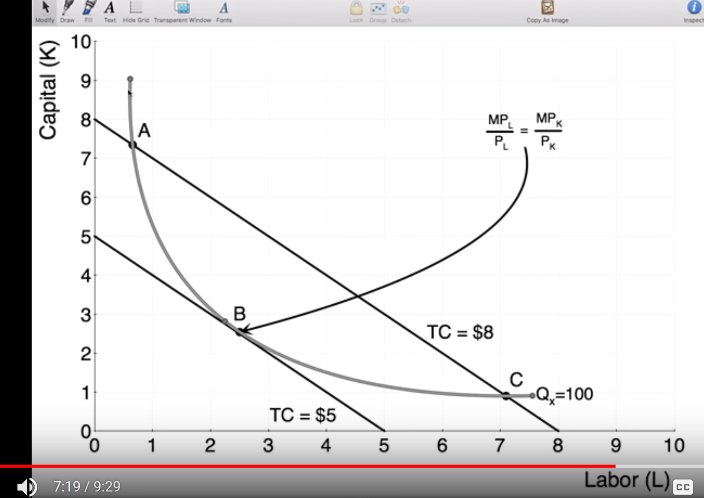

1. What is this telling us about the optimal production?

This is telling us that the optimal production is at B. This graph has the isoquant and isocost both in this graph. So, for one given output, what is the least that it would cost us. It shows that There are 3 points, A, B, & C that are on both the isocost line and isoquant curve.

1. Why is point B superior to points A and C?

Point B is superior because at point be, the same 100 units can be produced for TC = $5. At points A & C, the same 100 units is produced for cost = $8, therefore, B is cheaper than A or C for the same thing.

Question 6 – Given the following graph:

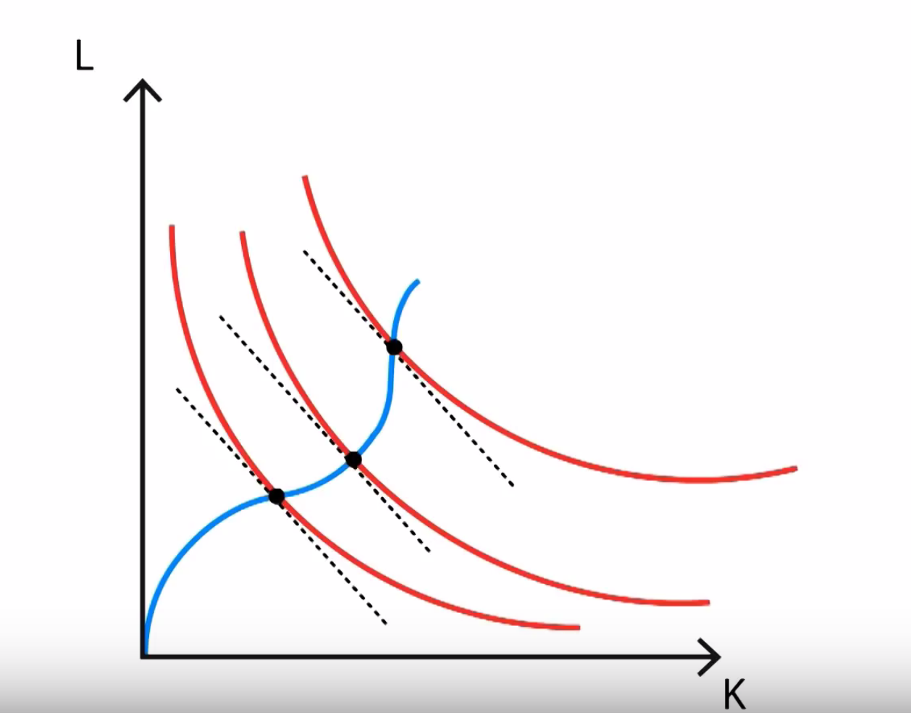

1. What are the “dotted” lines on this graph?

The dotted lines represent the slope of the curve at the point (black circle).

1. What are the red lines on this graph?

The red lines are the isoquants. Each point on a given curve represents the same amount of output.

1. What is the black circle (point) on the red lines where the dotted lines touch? What does this mean?

The black dots (points) on the graph represent the amount of capital and labor that was used to produce the given amount of output for that line.

1. Why are the red lines slightly “askew” from each other? What is that telling us? Does it make sense in the real world?

The red lines are slightly askew because each new line represents an increase in total production. Since there is a new value of total production, more capital and labor are required. It makes sense in the real world because in the real world to provide more production, more of either capital or labor is required to ramp up production, impossible to do otherwise.

1. What is the name of the blue line? What is this line potentially telling us?

The blue line is called the isocline. The isocline represents the most efficient path of expansion of output.

1. How does the “Law of Diminishing Returns” apply here?

The law of diminishing returns apply here when the slope of the curve approach 0 or infinite. When the slope approaches 0, then no matter how much more capital you put into it, to get the same output, there will be no change in labor. This is vice versa for when the slope approaches infinite.

Question 7 – Problem #2 (a) (page 100) - Kleiber, Christian; Zeileis, Achim. Applied Econometrics with R (Use R!) (Page 100). Springer New York. Kindle Edition.

Note: R code to pull data:

##

library("AER")

data("HousePrices")

##

2. Estimate a regression for the HousePrices data taken from Anglin and Gen¸cay (1996), which contain prices of houses sold in the city of Windsor, Canada, during July, August, and September 1987. These data are also used in the textbook by Verbeek (2004).

(a) Fit a multiple linear regression model to the logarithm of the price, using all remaining variables as regressors. Experiment with models containing lot size, number of bathrooms, number of bedrooms, and stories in logarithms and in levels, respectively. Which model do you prefer (Hint: use anova…)?

After performing ANOVA tests for comparison, against models that had one of the variables removed, most of the models were considered to not be significantly different. However, one that was not was the variable for the number of bedrooms which was not deemed to be as significant. Removing that variable slightly increased our R-squared from 0.6731 to 0.6733 and our adjusted R squared from 0.6664 to 0.6672. We also used the function for variance inflation factor in order to check for covariance, but this was not an issue for this data set. Therefore, our final model is log(price) ~ lotsize + bathrooms + stories + driveway + recreation + fullbase + gasheat + aircon + garage + prefer.

> library("AER")

> data("HousePrices")

> House_lm <- lm(price ~ ., data=HousePrices)

> summary(House_lm)

> vif(House_lm)

> no_beds <- update(House_lm, formula. = . ~ . - bedrooms)

> no_baths <- update(House_lm, formula. = . ~ . - bathrooms)

> no_stories <- update(House_lm, formula. = . ~ . - stories)

> no_driveway <- update(House_lm, formula. = . ~ . - driveway)

> no_recreation <- update(House_lm, formula. = . ~ . - recreation)

> no_fullbase <- update(House_lm, formula. = . ~ . - fullbase)

> no_gasheat <- update(House_lm, formula. = . ~ . - gasheat)

> no_aircon <- update(House_lm, formula. = . ~ . - aircon)

> no_garage <- update(House_lm, formula. = . ~ . - garage)

> no_prefer <- update(House_lm, formula. = . ~ . - prefer)

> anova(House_lm, no_bed)

> drop1(House_lm, test = "F")

> drop1(no_beds, test = "F")

> summary(no_beds)